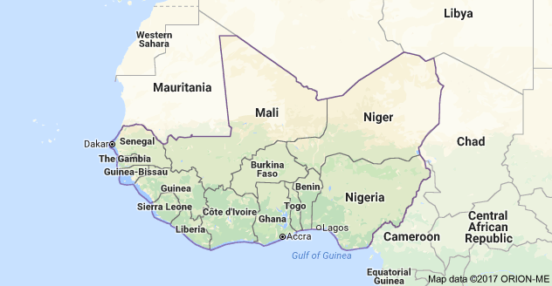**WAWA (Niger) Visitors’ Welcome Pack**

|  |  |
| --- | --- |
| **Scope** | **Regional People Management Framework** |
| **Introduction** | The nature of WaterAid’s work necessitates working in volatile and sometimes violent environments. At times this presents a threat to the security and well-being of our staff; an issue the organisation takes very seriously.  A Country Welcome Pack provides staff and visitors with a broad overview of the environment in which they are working or travelling to including essential security information good to know prior to visiting. It describes other factors that may not be included in a security plan such as currency information, cultural norms, local considerations, sensitivities, etc. |
| **Purpose** | The aim of this document is to inform short-term visitors of useful information that is important for their visit. Your welcome pack should:   * Provide a brief summary of the country including safety and security * Provide information on cultural practices * Provide information regarding airports and accommodation * Provide useful hints and tips regarding dress, communications, electricity, currency, eating out, getting around, health and climate. * Contain a short declaration to be signed by the visitor after the In-Country security briefing, whereby acknowledging that s/he is informed and understand the risks (informed consent). * To satisfy one of the requirements of WA’s duty of care.   Preferably visitors should be able to access this – or receive by mail – prior to departing for your country as a Pre-Departure brief. |
| **First Published** | **2016** |
| **First Revision** |  |

**CHAPTER 1: Global Security Framework**

**1.1 Global Security Framework**

* + 1. This document is part of the Global Security Framework that consists of policies, a toolkit, procedures and a template pack, as illustrated below.

Policies

Toolkit

Procedures

Templates

Global Security Policy

Emergency Number

Crisis Management

Medical Response & Evacuation

Repatriation of Deceased

Psychosocial Care

Incident Reporting

Kidnap

Security Handbook

Essential Security Package

Security Plan

Welcome Pack

‘RED’ Form

Contingency Plans

Risk Assessment

Context Analysis

Incident Report Form

International & Domestic Travel

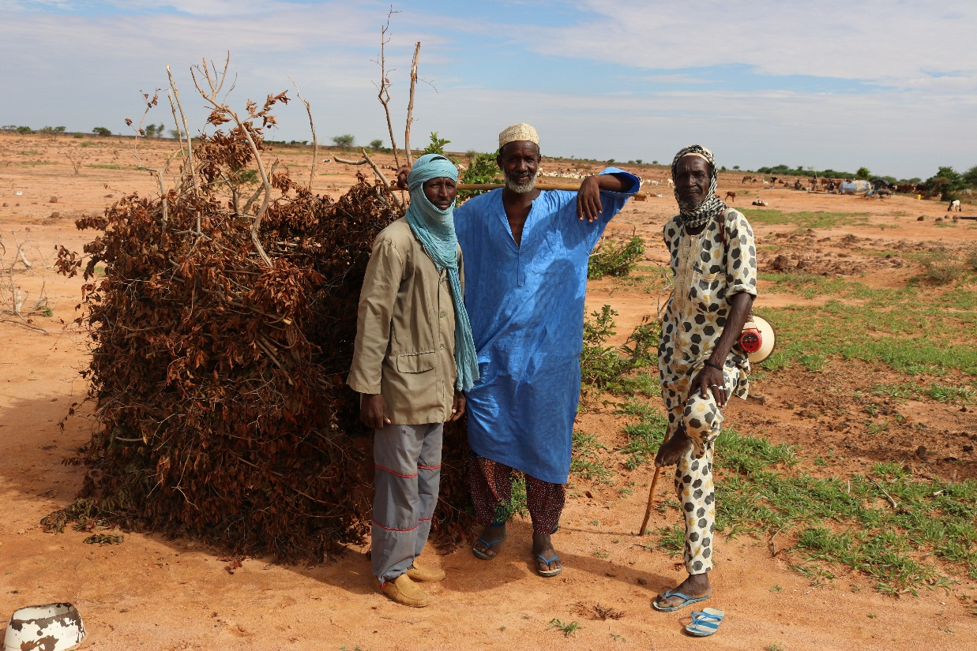

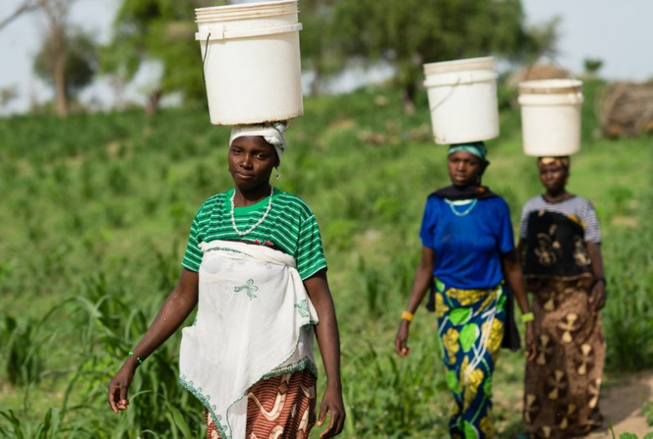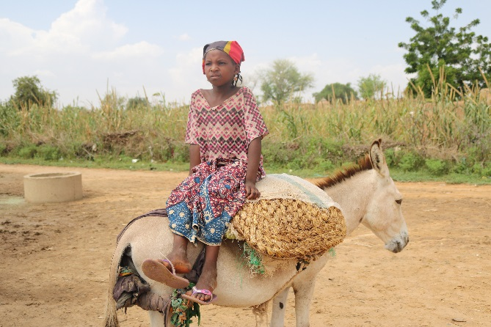

**CHAPTER 2: INTRODUCTION**

2.1.1 WaterAid Niger is often hosting international visitors from member offices, donors and supporters.

The aim of this Welcome Pack is to inform short-term visitors of useful information that is important for their visit. It is updated regularly to reflect current security situation in [insert country], and will also provide some useful information that visitors should know before starting their journey.

The document serves as a Pre-Departure Brief and will be supplemented by a verbal security briefing upon arrival to Niger.

**CHAPTER 3: SECURITY WELCOME PACK**

**3.1 Country Summary**

The Republic of Niger, located in Sub-Saharan Africa, is bounded on the north by Algeria and Libya to the east by Chad, on the south by the Federal Republic of Nigeria and Benin, to the west by Burkina Faso and northwest by Mali. By area, Niger is one of the largest countries in West Africa with 1,267,000 km². Its climate is tropical Sudan type. Niger's population mainly lives from agriculture, livestock, fishing and crafts.

Capital city of Niger, Niamey is located on the Niger River in the far west of the country. It developed around the year 1900 from a place where there were Fulani Koira, Gaweye, Kalley, MAOUREY and Zongo villages. Niamey is divided into two parts. The most important part of the city lies on the left bank and counts several neighborhoods such as Kwarakano, Plateau I and II. On the right bank, also known as Harobanda we have neighborhoods like GAWEYE or Kennedy Bridge.

Targeting nomadic, riverine and island populations to carry out its activities, Wateraid Niger has chosen to intervene in two Regions where there is a strong representation of these populations. This is the region of Dosso, in the rural commune of Soucoucoutan and the region of Tillabéry in the rural municipality of Sinder.

**Cultures, customs and practices**

Different ethnic groups live side by side in the country. The largest of these is Hausa, which is the most spoken language at 55.6% followed by Zarma and Songhai. The dominant religion in Niger is Islam, practiced by 90% of Nigeriens. Nevertheless, there is a large Christian community that coexists peacefully with Muslims.

**Weather**

The rainy season lasts 3 to 4 months (from June to September). During this period, malaria is very common

due to the increase in the number of mosquitoes. Make sure you have been treated for malaria before you

arrive and bring appropriate clothing (clothes with long sleeves, scarf, etc.)

**3.2 Entry Requirements**

In addition to the passport, an entry visa to Niger is required for visitors who are not part of the CEDEO area. The validity of the tourist visa is 3 months. It can be obtained from the Niger embassy in Paris for 60 euros or from the Niger embassy in Belgium for 50 euros.

Some health precautions should be taken before embarking on a trip like a preventive treatment of malaria (especially those coming from London. The certificate of vaccination against yellow fever is required at the entrance of the country.

For personalized information on the medical risks related to your trip and their prevention (vaccines, chemoprophylaxis against malaria, protection against mosquito bites ...) we recommend you to consult the site of the Center of medical advice to travelers of the Pasteur Institute of Lille. Click on the link below to go directly to the sheet "Health and Vaccination Tips for Niger": <https://www.pasteur-lille.fr/vaccinations-voyages/?pays=Niger>

On your arrival in Niamey, WaterAid Niger’s driver will pick you at the airport. His name is Mahamane Bachir Ado and you can reach him on 00227 96 88 58 85. He will meet you at the exit of the airport with the password you sent us before your arrival. Be sure to check the password before getting into the vehicle

**3.3 Safety & Security**

**Political**

The political situation is currently rather calm. President Mahamadou Issoufou was reelected for a second term in office on 20 March 2016. Elections were met by widespread allegations of voter fraud and general electoral maleficence, triggering notable protests in the country's larger urban centers. Ongoing opposition towards Issoufou, as well as ongoing socio-economic and religious issues, are likely to continue serving as catalysts for unrest in the country. Moreover, increasing discontent over insecurity in the country's south eastern regions will remain a challenge to Issoufou's administration in the medium-term.

**Criminality**

The crime rate is unfortunately rising in Niamey because petty crime is more and more present. Pickpocket - Mugging, car-jacking and assault are common in urban areas. Both violent and non-violent crime is a concern in Niger including in the capital Niamey. Most street crimes are petty in nature, but can quickly turn violent if victims resist in any way. We urge visitors to take care of their property and avoid displaying valuables, and to avoid holding cameras, phones, and similar valuables visible. Foreign visitors should NOT walk alone – and never after dark. Avoid routine habits or behavior and make sure to always tell your location to someone from WaterAid

**Traffic**

Traffic in Niamey is quite dense due to the rainy season. This makes some axes impractical. Also, some roads are in poor condition, traffic is especially more difficult during peak hours. WaterAid Niger will facilitate visitors’ needs for transport while in the country. You should not use Taxis or public transport.

**Health**

Health standards in Niger are low, with limited medical facilities in Niamey, and less in rural areas of the country. Medical equipment and medications are in short supply. WaterAid Niger has identified the following medical facility as its main source for medical assistance:

Name: Clinique Gamkalley

Location: BP 324

Tel.: +227 20 73 20 33 / 20 73 46 39

Name : Clinique Pasteur

Location : Near Lycée Lafontaine

Tel.: +227 20 72 50 16

**Pre-Departure:**

Before leaving, visitors must consult TravelGuard travel advise and analysis of Niger. In addition, visitors could regularly check the website of the Ministry of Foreign Affairs by searching "Advice to travelers". This site, regularly updated, indicates for each country the places to avoid or discouraged according to the news. Click on the link below to directly access the Niger profile: <https://www.diplomatie.gouv.fr/fr/conseilsaux-voyageurs/conseils-par-pays/niger/#securite>

On your arrival, a safety briefing will be done by the security focal point whose references are as follows:

Name: Sandrine Nignon

Mobile number: 00227 92 60 28 27

Email: SandrineNignon@wateraid.org

**3.4 Nice to Know**

FCFA (XOF) is the local currency. Though major hotels accept credit card such as Visa, MasterCard, we recommend that you carry some cash with you to cater for your petty expenses.

The current exchange rate is[1]:

≈ 573,674 FCFA for $1.00.

≈ 655,957 FCFA for 1€

≈ 732,379 FCFA for £1

If you need to change money, you can contact WaterAid Niger driver Mahamane Bachir Ado: (+227) 96 88 58 85

Telephone, fax and telex services as well as Internet cafes are available in Niamey and in the hotel. The largest telephone networks are Airtel, Orange and Etisalat (Moov). You will not need to buy a SIM card, the WANi office will provide you with one. Only credit cards will be at your expense and the WANi staff will help you get them.

Electricity in Niger is 220 Volts. Plugs have two heads. If your appliances plug has a different shape, you may need a plug adapter. The country programme team can help you get them.

You are booked at Soluxe Hotel, located near to the center of Niamey, which has qualified staff and unmatched comfort in the hotel industry in Niamey. The hotel includes a restaurant and has internet facilities The hotel address is: N°1100 Avenue de l’Afrique. Telephone: (+227) 20 33 22 22, (+227) 99 51 07 04

Email: [csi-niger@soluxeint.com](mailto:csi-niger@soluxeint.com), Site. [www.soluxeint.com](http://www.soluxeint.com). The workshop will also be held in the same hotel

During your visit, breakfast and lunch will be provided by the hotel. However, per diem will be provided to you to cover dinner expenses. If you don’t want per diem, please let us know. So, the dinner costs will be directly put in the invoice. For your movements, please do not take a taxi. We can arrange your trips out of the hotel with the WANi drivers

The official language of Niger is French but there are several dialects such as Hausa or Zarma that are spoken in Niamey and in different parts of the country.

During your visit, breakfast and lunch will be provided. However, per diem will be provided to you

to cover diner expenses.

**3.5 Key Contacts**

The Niger's telephone code is +227

|  |  |  |
| --- | --- | --- |
| WaterAid Niger  48, Rue Yantala Haut BP 11026  Landline : +227 20 35 01 76  Fax : +227 20 35 01 78 | | |
| Name & Position | Phone number | E-mail |
| Oumarou Hamani, Country Director | +227 96 87 67 68 | [OumarouHamani@wateraid.org](mailto:OumarouHamani@wateraid.org) |
| Boubacar Tanimou, Manager Finance & IT | +227 96 81 83 33 | [BoubacarTanimou@wateraid.org](mailto:BoubacarTanimou@wateraid.org) |
| Moumouni Kimba Alfari, Manager Programme & Advocacy | +227 96 50 32 74 | MoumouniKimbaAlfari@wateraid.org |
| Sandrine Nignon, Security Focal Point | +227 92 60 28 27 | SandrineNignon@wateraid.org |
| Police Station near to the Office | +227 98 93 66 19 |  |
| Fire brigade | 18 |  |
| SAMU/Ambulance | 17 |  |

1. Exchange rate as of August 20th 2018